Using MS Access on a Mac with UB VDI (Virtual Desktop Infrastructure)

- Open UB VDI and select VMWare Horizon HTML Access: https://ubvdi.buffalo.edu/
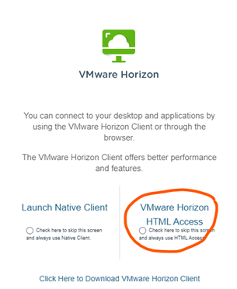

- Sign in with your credentials and verify with Duo.

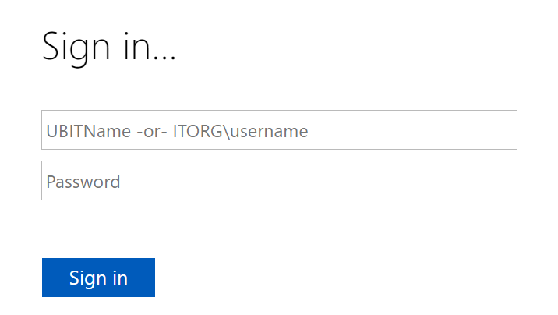

- Next, select the option to connect to the “My Virtual Public Site”. This will load a remote UB Windows system which runs in your web browser.

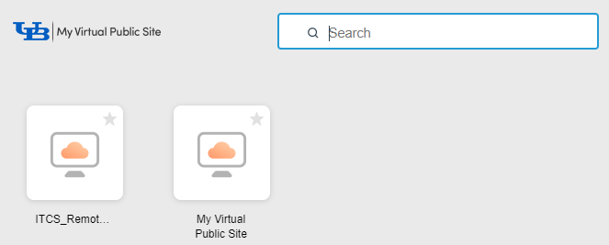

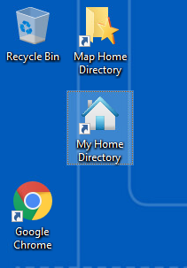
To ensure your homework or project data files are permanently saved, make sure to save your files to the Home directory on the remote Windows computer. This is also referred to as the S: drive on that computer.

If you need to transfer your files to the remote Windows computer, simply open Google Chrome on the remote desktop, and download the zipped data file from the email I sent to you. Make sure you extract the homework data files to your S: drive after you download it.

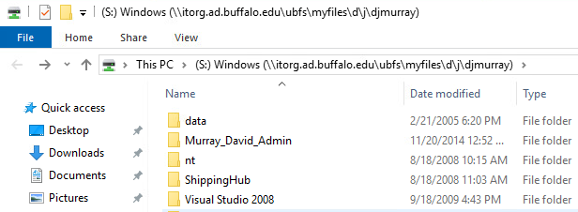

You can submit files to UBLearns in the same way using the web browser on the remote desktop.

